**HAX CMS File Conversion Microservice System Use**

**Training Guide**

# Table of Contents

Table of Contents 1

Compatible File Types 2

Environment Setup 2

Get the Code 2

Build the Container 3

Listing our Images 3

Using the Microservice Container 3

Additional Resources 4

Windows Command Line 4

Choose Output File Location 5

Creating a Test File 5

# Compatible File Types

The attached document highlights the file input and output types that have been tested to convert successfully.

<https://docs.google.com/spreadsheets/d/1vYWvgQ7T0PwcnToshBOIv8cSMOaXGcJfMpO0ptaiZrY/edit?usp=sharing>

NOTE: Although additional file types are listed within the [official documentation](https://pandoc.org/), our team was instructed to test the microservice for the file types listed within the table. You are free to try additional types, but they may or may not work due to our embedded parameters.

# Environment Setup

There are two primary ways to run the microservice:

1. You can use the command line on your own device with Docker installed.
   1. [Install](https://docs.docker.com/get-docker/) Docker.
   2. Open your command line.
2. You can use [Docker Playground](https://labs.play-with-docker.com/).
   1. Sign up for/log in to service.
   2. Create **ADD NEW INSTANCE** in the Docker Playground.

NOTE: The following material will demonstrate the process for running the microservice on Linux/Mac/Windows PowerShell or Docker Playground. The Additional Resources section will contain information regarding how to use the Windows command line. If you need to learn how to create a test file for conversion, it can be found there as well.

# Get the Code

1. Run the following command in the command line to .

|  |
| --- |
| **git clone https://github.com/elmsln/Pandoc-Service.git** |

2. Navigate to the **Pandoc-Service/** directory.

|  |
| --- |
| **cd Pandoc-Service** |

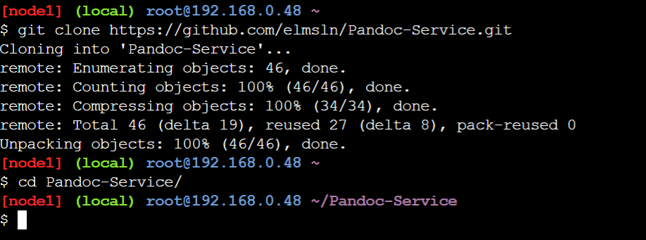

# Build the Container

3. Use the **docker build** command to build our application into an image. We are going to use the **-t** flag to tag this image with a descriptive name. We will add a **.** to indicate which directory the **Dockerfile** can be found. **.** is shorthand for "the current directory".

|  |
| --- |
| **docker build -t pandoc-service .** |

# Listing our Images

4. Let's take a look at our images to see our new **pandoc-service** image.

|  |
| --- |
| **docker images** |

# Using the Microservice Container

NOTE: If you do not have a file to convert at this point, you can create one for testing **NOW** using the method described in the “Creating a Test File” section of the Additional resources.

5. Return to your previous directory.

|  |
| --- |
| **cd ..** |

6. In order to convert a file, you will use the following format.

|  |
| --- |
| **docker run -it --rm -v "$(pwd):/src" pandoc-service <input-filename>.txt -s -o <output-filename>.html** |

The following example uses a specific file name to demonstrate the use.

|  |
| --- |
| **docker run -it --rm -v "$(pwd):/src" pandoc-service pandochtmltest.txt -s -o output.html** |

7. After running the previous command, use the **ls -la** command to the file converted successfully.

|  |
| --- |
| **ls -la** |

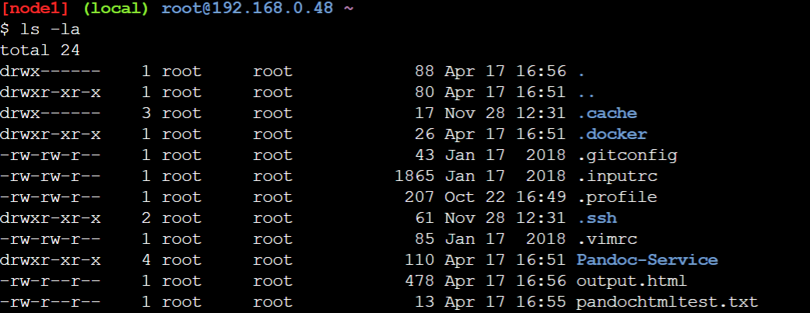

# Additional Resources

## Windows Command Line

To convert a file using the microservice on a Windows device, PowerShell will work just fine and use the process described previously. However, if you want to use the Windows command line you can use the following format which varies slightly from the other command.

|  |
| --- |
| **docker run -it --rm -v "%cd%:/src" pandoc-service "<input-filename>.txt" -s -o "<output-filename>.html"** |

## 

## Choose Output File Location

If you wish to convert the file and have it be output to a directory other than the one you are currently in, use the following format.

Linux/Mac/Windows PowerShell:

|  |
| --- |
| **docker run -it --rm -v "$(pwd):/src" pandoc-service <input-filename>.txt -s -o <output-filename>.html | mv <output-filename> <new/file/location>** |

Windows Command Line:

**docker run -it --rm -v "%cd%:/src" pandoc-service "<input-filename>.txt" -s -o "<output-filename>.html" | mv <output-filename> <new/file/location>**

## Creating a Test File

In order to create a file to test the microservice with, run the following command. This will be necessary for using the container on Docker Playground.

|  |
| --- |
| **nano "Pandoc Test.txt"** |

Alternatively, in PowerShell you will use:

|  |
| --- |
| **bash -c "nano 'Pandoc Test.txt'"** |

This is the screen that should appear. Simply type in whatever text you want so there is something to save. It can be as simple as “This is a test file for Pandoc”.

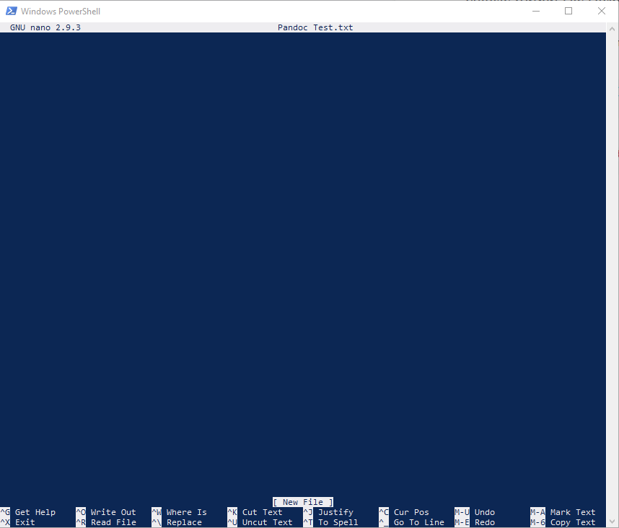

When you are finished, press the key combo “CTRL X” and you will be presented with the following:



Press the ‘Y’ key to save or the ‘N’ key if you want to discard the file. The file will save as a .txt file which will be ready for conversion.